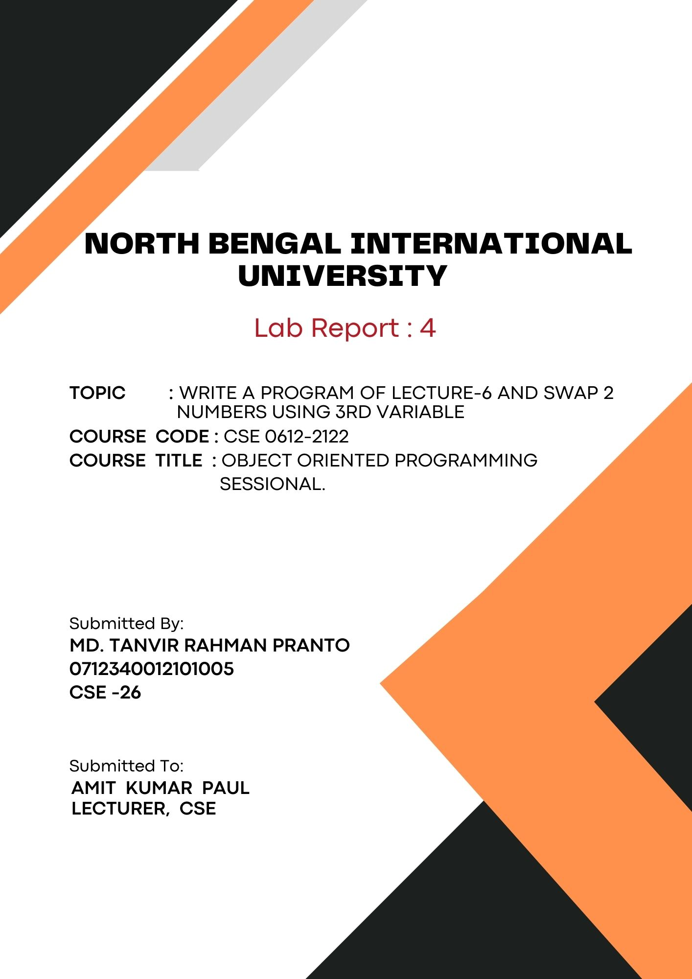
1

Write a program of Lecture-6 and swap 2 numbers using 3rd variable:

# Simple example of using pointers printing the address and value:
Code:
#include <iostream>
using namespace std;

int main() {
int num = 10;
int *ptr;

ptr = &num; // Store the address of num in ptr

cout << "Value of num: " << num << endl;
cout << "Address of num: " << &num << endl;

cout << "Value of num using pointer: " << *ptr << endl;
cout << "Address stored in pointer: " << ptr << endl;

return 0;
}

Output:
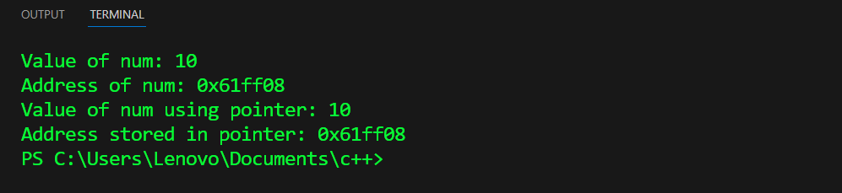

# c++ pointer program to swap two number using 3rd variable:
Code:
#include <iostream>
using namespace std;

void swap(int *a, int *b) {
int temp;
temp = *a;
*a = *b;
*b = temp;
}

int main() {
int num1, num2;
cout << "Enter first number: ";
cin >> num1;
cout << "Enter second number: ";
cin >> num2;

// Print numbers before swapping
cout << "Before swapping:" << endl;
cout << "num1 = " << num1 << ", num2 = " << num2 << endl;

// Swap the numbers
swap(&num1, &num2);
cout << "After swapping:" << endl;
cout << "num1 = " << num1 << ", num2 = " << num2 << endl;

return 0;
}
Output:
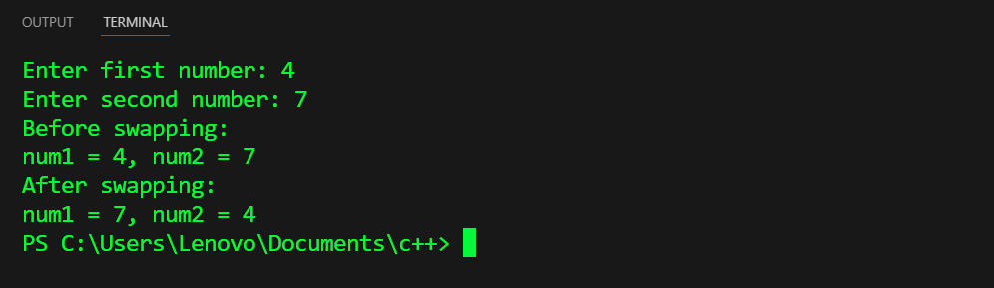

#c++ changing value pointed by pointers:
Code:
#include <iostream>
using namespace std;

int main() {
int num = 20;
int *ptr;
ptr = &num;

cout << "Initial value of num: " << num << endl;

*ptr = 50;

cout << "Value of num after changing through pointer: " << num << endl;

return 0;
}

Output:
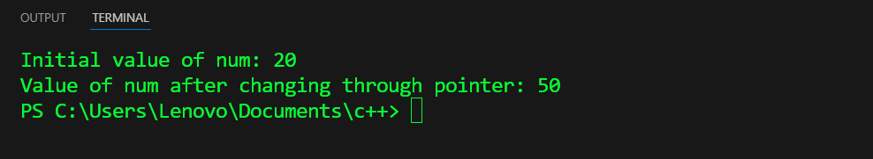

#the address of 'a' variable to teh third element of an array 'ptr':
Code:
#include <iostream>

int main() {
int a = 42;
int *ptr[5]; // Array of pointers to integers

// Assigning the address of 'a' to the third element of 'ptr'
ptr[2] = &a;

// Displaying the address and value
std::cout << "Address of 'a': " << &a << std::endl;
std::cout << "Address stored in ptr[2]: " << ptr[2] << std::endl;
std::cout << "Value pointed to by ptr[2]: " << *ptr[2] << std::endl;

return 0;
}

Output:
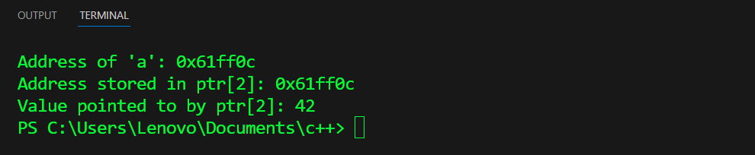

# Array to pointer to String:
Code:
#include <iostream>
#include <cstring>

int main() {
// Define an array of characters
char array[] = "Hello, world!";

// Create a pointer to the array
char *pointer = array;

// Display the string using the pointer
std::cout << "The string is: " << pointer << std::endl;

return 0;
}
Output:
